August 15th, 2010
Hi
Not too much to write about.
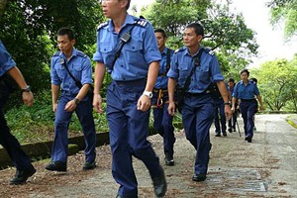

About 10 days ago, an Air NZ pilot went missing on a hike in the New Territories. He, together with another Air NZ pilot, set off from Hok Tau reservoir (a small reservoir you have been to but you may not remember) and along the Pat Sing Leng range intending to end at Tai Mei Tuk (Plover Cover) bus terminus. The two separated towards the end of the walk while the other pilot took a rest. They agreed to meet at the end of the track to catch a bus back to their hotel together. However, this never happened. The other pilot did not see him at the bust stop so eventually returned to the hotel to get help, with police beginning a search using tracker dogs later that night. His body was discovered the other day not far from the bus stop. He made it to the Plover Cove Visitor Centre and from there it is just about 400 m down the road to the bus stop. His body was found about 200 m from the visitor centre in thick scrub off the road. There is no suspicion of foul play – no injuries and all his belongings were intact. About 200 search and rescue people with helicopter support were involved in the search. Very puzzling that he did not just walk down the main road from the visitor centre to the bus stop.
Here is an issue that would test the wisdom of a Solomon. A HK man who changed his sex wants to marry but is not allowed to do so because her/his birth certificate (and genes) says male even though his/her latest ID card says female. She has taken her case to court to get a ruling. How would you rule?
It has certainly been a week when the news has been dominated by the disasters around the world. I gave a donation towards the Pakistan relief – twice! It is hard to see all that suffering on TV and not to try to do something to help. I gave to Pakistan relief and not China relief as the former seems more desperate for funds. Also the HK government is to give HK$50 million for the China relief – but zilch for Pakistan!!! I also prefer to give to organisations where you can be sure the money will be used for relief and not be lost through corruption. Hence I gave to World Vision and MSF (Doctors without Borders). The local government in the affected province in China has 'requested' that all NGO charities hand over their money; given the extreme levels of corruption by provincial governments in China, you can be sure that a lot of the funds will be siphoned off by corrupt officials.
There are also the fires in Russia. I read an article that puts much of the blame for these squarely on the shoulders of Putin and his autocratic government as they had reduced the number of forest protection officials by 90%! And then to bolster his own image, we see on TV images of Putin 'flying' a plane on a water-bombing sortie, which I am sure would have distracted the fire fighters from doing their job properly. Another article was talking about the decision of Russia to stop exporting grain though losses incurred because of the fires. While this will help to feed the people of Russia, people in other countries, and especially poor people, will go hungry. The writer also discussed that as the effects of global warming increase around the world, other countries will probably take similar actions leading to large-scale starvation especially in poor countries and the possibility of massive migrations of people to places where they may be able to get food (and, of course, water which countries will also try to protect as global warming increases).
No doubt you heard/saw the incident of the 'JetBlue' attendant exiting the plane (and presumably his job) down an emergency chute. A very dangerous thing to do (the chutes deploy with such force that they could kill anyone on the ground that they hit) but still, one cannot help but feel some sympathy for the guy. I can remember (just!) many years ago when being an cabin crew attendant was a very sought-after job glamorous job with many attendants even having university degrees. No longer!
I mentioned last week about the Octopus card company selling customers' data. Now it has been revealed that at least six (currently unnamed) banks have been doing the same thing!
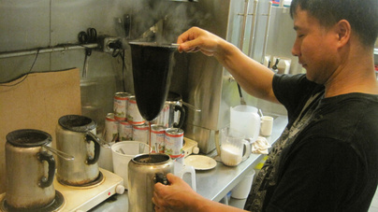
Yesterday, in HK, there was a semi-international HK milk-tea ('cha chaan teng') making competition (made from black tea and evaporated – not condensed - milk). Have you ever had this kind of tea, which is very common in dai pai dongs and restaurants here (often accompanied by pineapple buns and egg tarts- 'daan tarts')? It is a HK speciality and is even becoming popular now in Guangdong. The competition was won by a HK man. (Picture on right not part of the competition).
The Women's world softball tournament in being held in Venezuela. During a game against the Netherlands, a HK women was wounded by a stray bullet. Apparently the use of guns is common in the area where the games are being held. She was taken to hospital and is now OK.
More problems with food in China. This time it is milk to which the female hormone oestrogen has been added. It has been causing girl toddlers to change into women!!
Today is the anniversary of the end of WWII (in the pacific).
That seems to all for now.
Cheers

